ACE INSTITUTE OF MANAGEMENT


Pokhara University
Faculty of Management



BACHELOR IN COMPUTER SCIENCE AND INFORMATION TECHNOLOGY (BCSIT)

PROJECT DOCUMENTATION FOR BLOOD DONATION FINDER
Course: Project II
Year/Semester: II/IV
Submitted by: Group 7
Aryan Mainalee
Sulav Tiwari
Deepesh Bastola

Submitted to:
Sanju Shrestha

CERTIFICATION
Supervisor Recommendation

Internal and External Examiners’ Approval Letter

ABSTRACT
The Blood Donation Finder is a real-time web-based platform designed to connect blood donors and recipients quickly during medical emergencies. The project aims to address the lack of a centralized and efficient blood donor management system in Nepal, where patients and families often face significant delays in finding compatible blood donors.
The proposed system enables donors to register their blood type, location, and availability, while recipients can submit urgent blood requests through an easy-to-use interface. Using automated matching based on blood group and geographical location, the platform instantly notifies suitable donors. The system also incorporates real-time communication through in-app chat, email notifications, secure authentication, and donor history management.
The platform is developed using modern web technologies including HTML, CSS, JavaScript, Node.js, Express.js, MySQL, and Socket.io. A feasibility study confirms that the project is technically, operationally, and economically viable. By replacing manual donor search methods with a structured digital solution, the Blood Donation Finder is expected to reduce emergency response times, improve donor participation, and strengthen blood donation services in Nepal.

ACKNOWLEDGEMENT
We would like to express our sincere gratitude to our project supervisor, Mr. Sanju Shrestha, for his valuable guidance, encouragement, and continuous support throughout the development of this project.
We would also like to thank our institution, faculty members, and classmates for providing the necessary resources, knowledge, and constructive feedback that contributed to the successful completion of this project.
Special appreciation goes to all the authors, researchers, and organizations whose published works and resources helped us understand the challenges of blood donation systems and healthcare technology.
Finally, we thank our families and friends for their motivation, patience, and support during the preparation of this project proposal.

Contents
CHAPTER 1: INTRODUCTION 1
1.1 Background of the Study 1
1.2 Statement of the Problem 1
1.3 Objectives of the Study 2
1.4 Scope of the Study 2
1.5 Limitations of the Study 3
CHAPTER 2: LITERATURE 4
2.1 Description of fundamental theories, general concepts and 4
terminologies related to the project 4
2.1.1 Blood Donation System 4
2.1.2 Blood Donation and Blood Groups 4
2.1.3 Health Information Systems 4
2.1.4 Real-Time Communication Systems 4
2.1.5 Database Management Systems (DBMS) 5
2.1.6 Web-Based Applications 5
2.1.7 Notification Systems 5
2.1.8 Donor Matching Concept 5
2.2 Review of the similar Projects and Theories 5
2.2.1 BloodConnect 5
2.2.2 HamroLifeBank 6
2.2.3 Blood Supply Chain Theory 6
2.2.4 Emergency Response Theory 6
2.2.5 Comparative Analysis of Existing Systems 7
Summary of Literature Review 7
CHAPTER 3: SYSTEM AND ANALYSIS DESIGN 8
3.1 System Analysis 8
3.2 Requirement Analysis 8
3.2.1 Functional Requirements 8
3.2.2 Non-Functional Requirements 10
3.3 Feasibility Analysis 11
3.3.1 Technical 11
3.3.2 Operational 11
3.3.3 Financial 11
3.3.4 Schedule 12
3.4 Data Modeling 12
3.5 Process Modelling 12
3.6 System Design 15
3.6.1 Architectural Design 15
3.6.2 Database Schema Design 17
3.6.3 Interface Design (UI Interface / Interface Structure Diagrams) 19
3.6.4 Physical Model 19
CHAPTER 4: IMPLEMENTATION & TESTING 20
4.1 Implementation 20
4.1.1 Tools Used (CASE tools, Programming languages, Database platforms) 20
4.1.2 Implementation Details of Modules (Description of procedures/functions) 20
4.2 Testing 21
4.2.1 Test Cases for Unit Testing 21
4.2.2 Test Cases for System Testing 22
CHAPTER 5: CONCLUSION AND FUTURE RECOMMENDATIONS 23
5.1 Lesson Learnt 23
5.2 Conclusion 23
5.3 Recommendations 24
APPENDICES 25
REFERENCES 32

List of Tables
Table 1: Comparative Analysis of Existing Systems 17
Table 2: Test Cases for Unit Testing 31
Table 3: Test Cases for System Testing 32

List of Figures:
Figure 1: Use Case Diagram (Admin) 19
Figure 2: Use Case Diagram (Donor) 19
Figure 3: Use Case Diagram (Organization) 20
Figure 4: Flowchart 24
Figure 5: Architecture Diagram 26
Figure 6: ER Diagram 28

CHAPTER 1: INTRODUCTION

1.1 Background of the Study
Blood is an essential component of healthcare and is required during surgeries, accidents, childbirth complications, and the treatment of various diseases. Timely availability of blood can save lives, yet many hospitals and blood banks face shortages, particularly during emergencies. Research indicates that effective blood supply management remains a significant challenge worldwide and requires improved coordination between donors, blood banks, and healthcare institutions (Mdpi.com., 2023).
In Nepal, finding a compatible blood donor often depends on personal contacts, social media posts, and manual communication methods, which can result in significant delays. Studies on voluntary blood donation practices in Nepal show that although many individuals possess a positive attitude toward blood donation, efficient mechanisms for connecting donors and recipients are still limited (NepJOL., 2023). Furthermore, blood transfusion services in Nepal face challenges related to donor availability, blood shortages, and coordination during emergencies (ResearchGate., 2024).
To address these challenges, this project proposes the development of a Blood Donation Finder, a real-time web platform that connects blood donors and recipients quickly and efficiently. Existing platforms such as BloodConnect and HamroLifeBank demonstrate the potential of technology-driven blood donation services, but there is still a need for an accessible and real-time solution focused on emergency blood requirements in Nepal (BloodConnect) (HamroLifeBank).

1.2 Statement of the Problem
The existing blood donation system in Nepal lacks a centralized and real-time platform for connecting blood donors with recipients during emergencies. As a result, patients and their families often spend valuable time searching for compatible donors through phone calls, social media, and personal networks.
Research has shown that disruptions in blood supply and inefficient donor management can significantly affect healthcare services, particularly during emergencies, disasters, and public health crises (ScienceDirect., 2023). In Nepal, challenges such as outdated donor records, difficulty locating rare blood groups, and delays caused by manual processes further worsen the situation (ResearchGate., 2024).
Therefore, there is a need for a reliable web-based system that can efficiently connect blood donors with recipients, reduce response time, and improve access to blood during critical situations.

1.3 Objectives of the Study
General Objective
To develop a real-time web-based Blood Donation Finder that enables fast and efficient connections between blood donors and recipients during medical emergencies.
Specific Objectives
- To create a donor registration and management system.
- To enable users to post blood requests online.
- To automate donor matching based on blood type and location.
- To provide real-time notifications to compatible donors.
- To facilitate communication between donors and recipients through an integrated chat system.
- To maintain a secure database of donor and blood request information.
- To improve the efficiency of emergency blood donation services in Nepal.

1.4 Scope of the Study
This study focuses on the design and development of a web-based Blood Donation Finder platform for use within Nepal. The system allows donors, recipients, organizations, and administrators to interact through a centralized platform.
The project includes features such as user registration, authentication, donor profile management, blood request creation, donor matching, real-time notifications, chat functionality, donation history tracking, and administrative monitoring. The system is developed using HTML, CSS, JavaScript, Node.js, Express.js, MySQL, and Socket.io technologies.

The study is limited to developing and testing the software platform and does not include integration with national healthcare databases, hospital information systems, or government health services.

1.5 Limitations of the Study
Although the proposed system offers significant improvements over traditional donor search methods, several limitations exist:
- The platform depends on internet connectivity and access to digital devices.
- Donor availability information relies on users updating their status regularly.
- The system cannot guarantee donor response after notifications are sent.
- Integration with hospitals, blood banks, and government healthcare systems is outside the scope of this project.
- SMS notification services may not be fully implemented due to financial and technical constraints.
- The project is developed within limited academic resources, budget, and timeframe.
- Security measures are implemented; however, full-scale healthcare compliance standards are beyond the scope of this academic project.

CHAPTER 2: LITERATURE

2.1 Description of fundamental theories, general concepts and

terminologies related to the project

2.1.1 Blood Donation System
A blood donation system is a framework that facilitates the collection, management, and distribution of blood from donors to recipients. The primary objective of such systems is to ensure the availability of safe and compatible blood during medical emergencies, surgeries, and treatments. Efficient blood management is essential because blood cannot be artificially manufactured and depends entirely on voluntary donations (ResearchGate., 2024).

2.1.2 Blood Donation and Blood Groups
Blood donation is the voluntary act of giving blood to help individuals requiring transfusions. Human blood is classified into different blood groups, including A, B, AB, and O, along with positive and negative Rh factors. Compatibility between donor and recipient blood types is crucial for successful transfusion procedures.
Studies have shown that increasing public participation in voluntary blood donation can significantly improve healthcare services and emergency response capabilities (NepJOL., 2023).

2.1.3 Health Information Systems
A Health Information System (HIS) refers to a digital platform used to collect, process, store, and manage healthcare-related information. Blood donation management systems are a specialized category of health information systems that facilitate donor registration, blood request management, and communication between stakeholders.

2.1.4 Real-Time Communication Systems
Real-time communication systems enable instant information exchange between users. In blood donation platforms, real-time communication allows donors to receive emergency notifications immediately after a blood request is submitted. Technologies such as Socket.io support bidirectional communication between users and servers, improving response times during emergencies.

2.1.5 Database Management Systems (DBMS)
A Database Management System is software used to store, organize, and retrieve data efficiently. In this project, MySQL is used to maintain donor records, recipient information, blood requests, donation history, and communication logs. Database systems ensure data consistency, integrity, and security.

2.1.6 Web-Based Applications
A web application is software that operates through a web browser using internet technologies. Web-based systems provide accessibility from multiple devices and locations. The proposed Blood Donation Finder utilizes HTML, CSS, JavaScript, Node.js, and Express.js to create an accessible and user-friendly platform.

2.1.7 Notification Systems
Notification systems automatically inform users about important events. In blood donation management, notifications play a critical role in alerting donors about urgent blood requirements. Email and real-time notifications can significantly reduce donor response time and improve emergency coordination.

2.1.8 Donor Matching Concept
Donor matching refers to the process of identifying suitable donors based on blood group compatibility, geographical location, and donor availability. Automated matching algorithms improve efficiency by reducing manual searching and ensuring faster responses during emergencies.

2.2 Review of the similar Projects and Theories

2.2.1 BloodConnect
BloodConnect is a digital platform designed to connect blood donors with recipients. The platform allows users to search for blood donors and request blood during emergencies. It promotes voluntary blood donation and provides a structured method of connecting donors with individuals in need.
The platform demonstrates how technology can improve accessibility to blood donors and reduce delays associated with traditional donor search methods. However, some features may depend on user participation and donor availability at the time of the request (BloodConnect, n.d.).

2.2.2 HamroLifeBank
HamroLifeBank is one of Nepal's most recognized blood donation applications. It enables users to register as donors, search for donors, and support blood donation campaigns. The application has contributed significantly to improving awareness and participation in voluntary blood donation across Nepal.
HamroLifeBank demonstrates the effectiveness of digital solutions in addressing blood shortages. However, there remains an opportunity to enhance emergency response through improved real-time communication and donor matching mechanisms (HamroLifeBank, n.d.).

2.2.3 Blood Supply Chain Theory
According to research on blood supply chain management, efficient coordination among donors, blood banks, hospitals, and recipients is essential for maintaining adequate blood availability. Delays in communication and poor information management often result in shortages and inefficient resource utilization (Mdpi.com., 2023).
The proposed Blood Donation Finder supports this theory by establishing a centralized platform that improves communication and coordination among stakeholders.

2.2.4 Emergency Response Theory
Emergency response theory emphasizes the importance of rapid communication and timely resource allocation during critical situations. Blood availability is a crucial factor in emergency healthcare services. Quick identification and notification of compatible donors can significantly improve patient outcomes (ScienceDirect., 2023).
The proposed system applies this theory by using real-time notifications and automated donor matching to reduce delays during emergencies.

2.2.5 Comparative Analysis of Existing Systems
Feature | BloodConnect | HamroLifeBank | Proposed Blood Donation Finder
Donor Registration | Yes | Yes | Yes
Blood Request Posting | Yes | Yes | Yes
Real-Time Notifications | Limited | Limited | Yes
In-App Chat | No | No | Yes
Donor Matching by Location | Yes | Yes | Yes
Donation History | Limited | Limited | Yes
Admin Dashboard | Limited | Limited | Yes
Real-Time Communication | Limited | Limited | Yes
Table 1: Comparative Analysis of Existing Systems

Summary of Literature Review
The reviewed literature and existing platforms indicate that digital blood donation systems improve donor accessibility, communication efficiency, and emergency response. Studies highlight the importance of donor management, blood supply chain optimization, and real-time communication in healthcare services. Existing platforms such as BloodConnect and HamroLifeBank provide valuable foundations; however, the proposed Blood Donation Finder aims to further enhance emergency donor matching, communication, and system efficiency through modern web technologies.

CHAPTER 3: SYSTEM AND ANALYSIS DESIGN

3.1 System Analysis
The Blood Donation Finder system is designed to address the inefficiencies in the traditional blood donation process in Nepal, where patients often struggle to find compatible donors during emergencies. The current system relies heavily on manual communication methods such as phone calls, social media, and personal networks, which are slow and unreliable.
The proposed system introduces a centralized, web-based platform that connects donors and recipients in real time. It analyzes user needs, system limitations, and operational challenges in existing processes. The system ensures faster communication, improved donor availability tracking, and automated matching based on blood type and location.
The system analysis focuses on identifying how users interact with the platform, including donor registration, blood request submission, donor matching, notifications, and communication between stakeholders.

3.2 Requirement Analysis
The requirement analysis defines the functional and non-functional needs of the system to ensure it meets user expectations effectively.

3.2.1 Functional Requirements
- User registration and login system for donors, recipients, and organizations
- Donor profile management including blood type, location, and availability
- Blood request creation by recipients
- Automated donor matching based on blood group and location
- Real-time notifications for emergency blood requests
- In-app communication system between donors and recipients
- Admin dashboard for monitoring users and requests
- Donation history tracking for donors

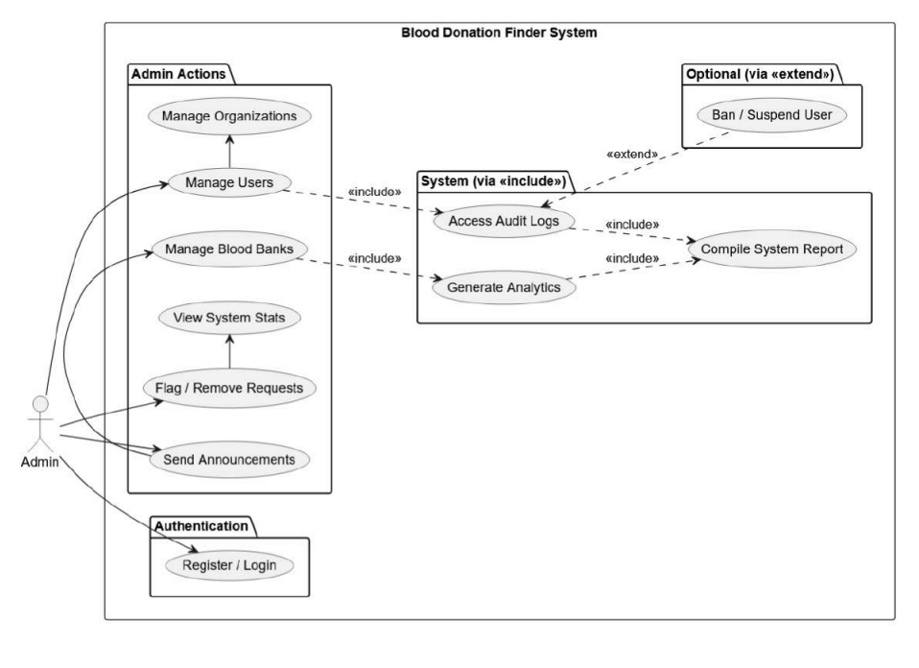
Figure 1: Use Case Diagram (Admin)
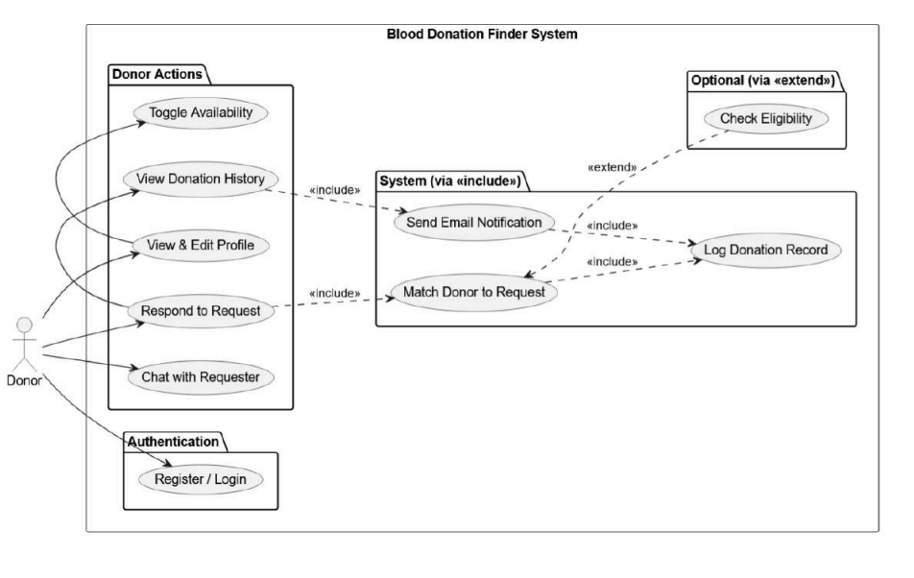
Figure 2: Use Case Diagram (Donor

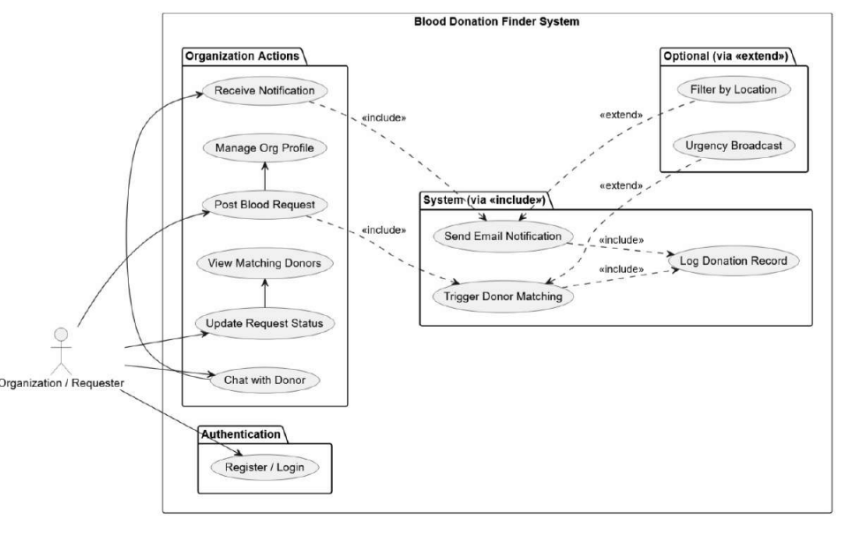
Figure 3 : Use Case Diagram (Organization)

3.2.2 Non-Functional Requirements
Non-functional requirements define system performance, reliability, and quality standards.
- Performance: The system should respond quickly with minimal delay during donor matching and notifications.
- Scalability: The platform should support increasing numbers of users without performance degradation.
- Security: User data, including personal and medical information, must be securely stored using authentication and encryption techniques.
- Usability: The system should have a simple and user-friendly interface suitable for all types of users.
- Reliability: The system should ensure high availability, especially during emergency situations.
- Maintainability: The system should be easy to update and maintain with modular architecture.

3.3 Feasibility Analysis
Feasibility analysis evaluates whether the proposed system is practical and achievable within technical, operational, financial, and time constraints.

3.3.1 Technical
The project is technically feasible using modern and widely adopted web technologies. The system uses HTML, CSS, and JavaScript for the frontend, Node.js and Express.js for backend development, MySQL for database management, and Socket.io for real-time communication.
These technologies are open-source, well-documented, and widely supported by developer communities. Real-time features such as notifications and chat are achievable using Socket.io, while secure authentication is implemented using JWT. Therefore, the system can be successfully developed with available technical resources.

3.3.2 Operational
The system is operationally feasible as it is designed with a simple and intuitive user interface. Users such as donors, recipients, and organizations can easily operate the system without requiring technical training.
The workflow for blood request submission, donor matching, and notifications is automated, reducing manual effort. The system can be maintained by a small administrative team after deployment, making it practical for real-world usage.

3.3.3 Financial
The project is financially feasible because it is developed using open-source technologies that do not require licensing costs. The main expenses include hosting, domain registration, and minimal server maintenance.
Since this is an academic project, development costs are minimal. Compared to the social benefit of saving lives through faster blood donation access, the cost of implementation is very low and justified.

3.3.4 Schedule
The project is feasible within the planned academic timeline of approximately 10 to 13 weeks. The development process is divided into structured phases including planning, design, implementation, testing, and documentation.
Each phase is assigned specific tasks such as requirement gathering, UI design, database creation, backend development, feature integration, and final testing. This structured approach ensures timely completion of the project within the academic schedule while maintaining quality output.

3.4 Data Modeling
Data modeling defines how data is structured, stored, and managed in the Blood Donation Finder system. It represents the relationship between different entities such as donors, recipients, blood requests, and administrators.
The system follows a structured relational model where:
- A User can act as a donor.
- A Donor has attributes such as blood group, location, and availability status
- A Blood Request is created by a recipient and linked to potential donors
- An Admin manages system activities and user records
The data model ensures consistency, reduces redundancy, and supports efficient retrieval of information during emergency situations.

3.5 Process Modelling
Process modeling describes the workflow and interaction between different components of the system.
The main processes in the Blood Donation Finder include:
- User Registration Process: Users register by providing personal details and blood group information.
- Login Process: Users authenticate using secure credentials.
- Blood Request Process: A recipient submits a blood request specifying blood type, location, and urgency.
- Donor Matching Process: The system automatically filters and identifies compatible donors based on blood group and geographical location.
- Notification Process: Matching donors receive real-time notifications through the system.
- Communication Process: Donors and recipients communicate through an integrated chat system after acceptance.
- Request Completion Process: Once blood is provided, the request status is updated to completed.
These processes ensure smooth operation and real-time response during emergencies.

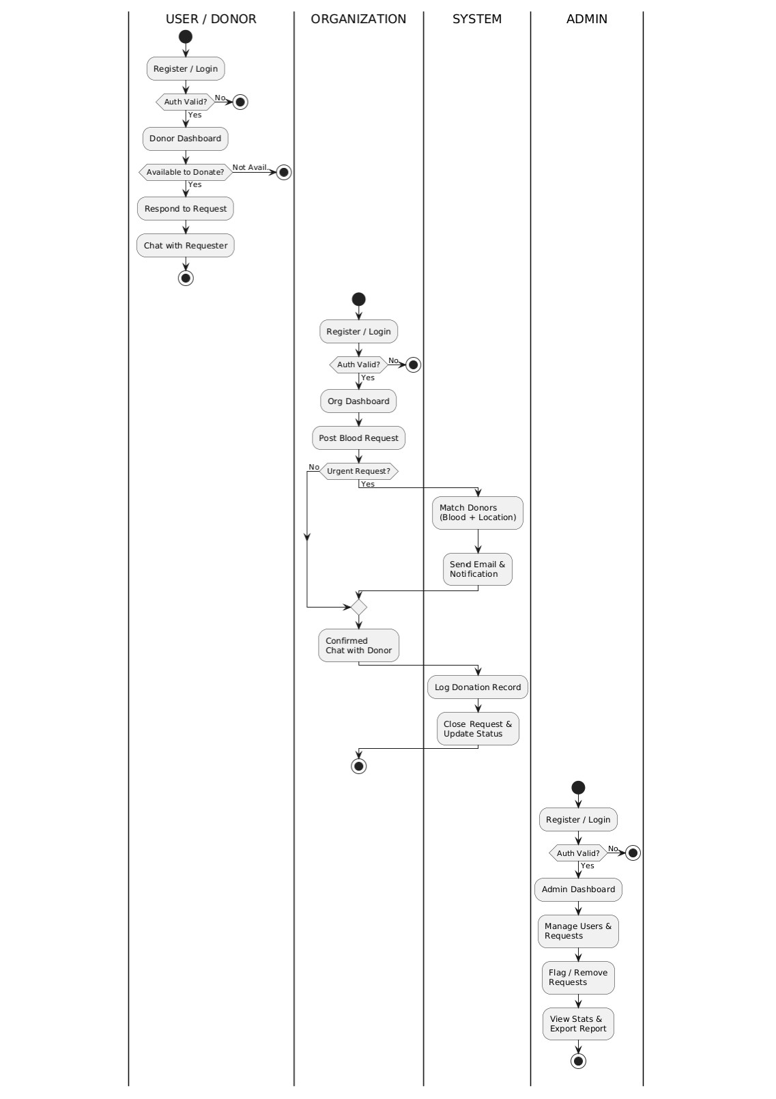
Figure 4: Flowchart

3.6 System Design
The system design of the Blood Donation Finder focuses on building a scalable, secure, and user-friendly platform that supports real-time blood donor matching and communication.

3.6.1 Architectural Design
The system follows a client-server architecture consisting of four main layers:
- Frontend Layer: Built using HTML, CSS, and JavaScript to provide user interaction.
- Backend Layer: Developed using Node.js and Express.js to handle business logic and API requests.
- Real-Time Communication Layer: Socket.io is used for instant messaging and notifications.
- Database Layer: MySQL stores all structured data such as user profiles, blood requests, and donation history.
This layered architecture ensures separation of concerns, scalability, and efficient system performance.

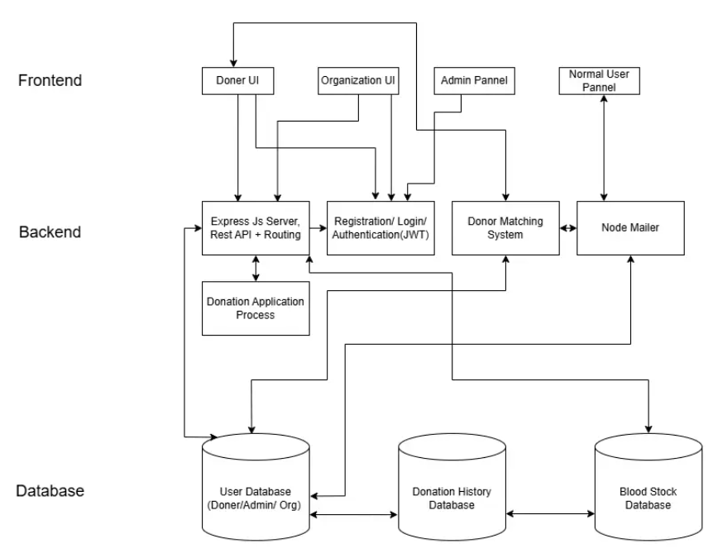
Figure 5: Architecture Diagram

3.6.2 Database Schema Design
The database is designed using a relational structure to maintain data integrity and efficient access. Key tables include:
- Users Table: Stores user information such as name, email, password, role, and contact details.
- Donors Table: Stores blood group, location, and availability status.
- Blood Requests Table: Stores request details such as blood type, urgency level, location, and status.
- Notifications Table: Stores alerts sent to donors regarding blood requests.
- Chat Table: Stores messages exchanged between donors and recipients.
- Donation History Table: Records completed donations.
Primary and foreign keys are used to maintain relationships between tables and ensure data consistency.

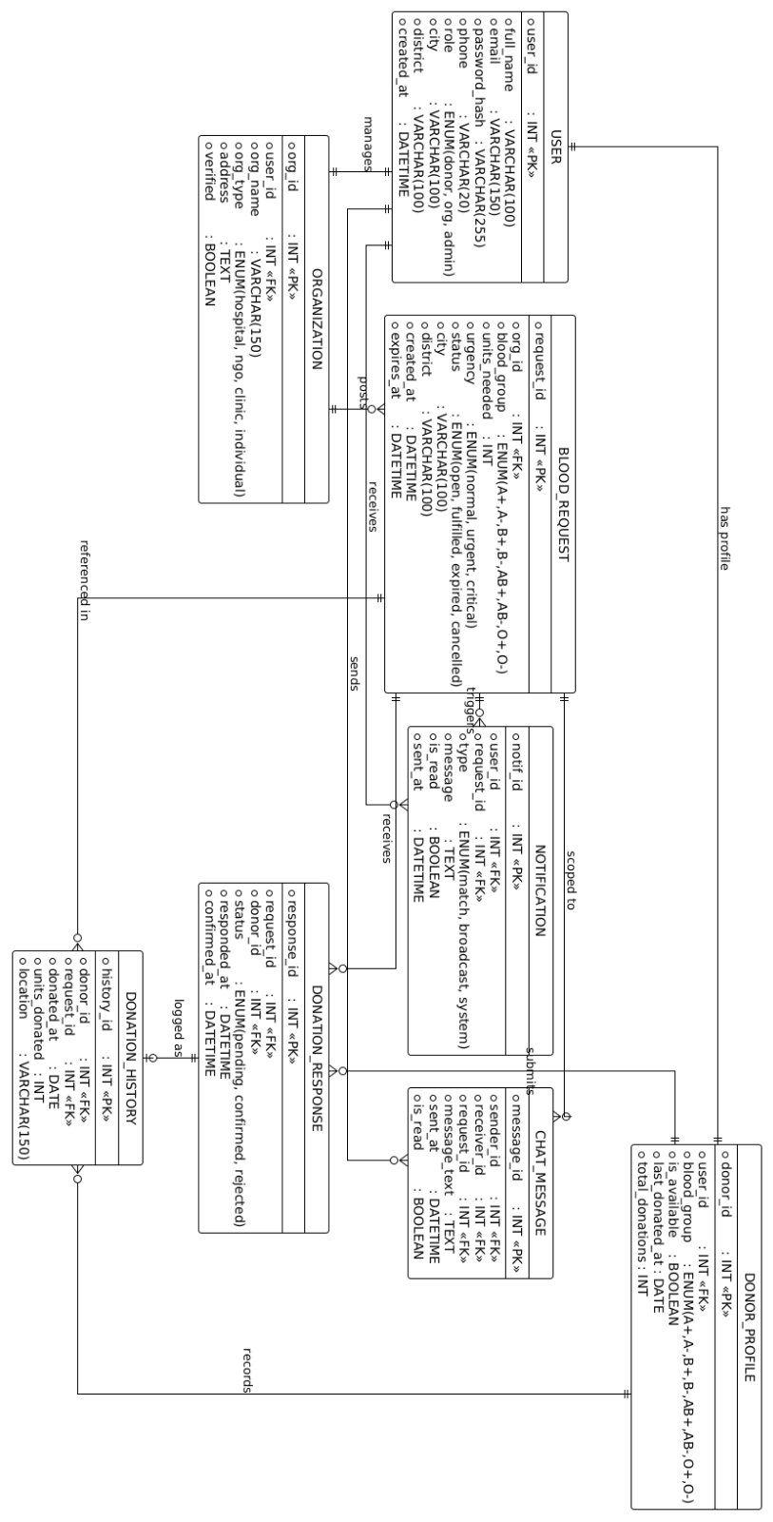

Figure 6: ER Diagram

3.6.3 Interface Design (UI Interface / Interface Structure Diagrams)
The user interface of the system is designed to be simple, responsive, and accessible for all users, including non-technical individuals.
Key interface components include:
- Home Page: Provides overview and access to login and registration
- User Dashboard: Displays donor/recipient information and active requests
- Blood Request Page: Allows users to create and view requests
- Donor List Page: Shows available donors based on matching criteria
- Chat Interface: Enables real-time communication between users
- Admin Panel: Allows system administrators to manage users and monitor activities
The design follows a minimal and clean layout to ensure ease of navigation and quick access during emergencies.

3.6.4 Physical Model
The physical model describes how the system is implemented in a real environment using hardware and software components.
The system is deployed on a cloud-based or local server that hosts the backend application and database. Users access the system through web browsers on devices such as mobile phones, tablets, or computers.
The physical setup includes:
- Web server for hosting Node.js application
- MySQL database server for data storage
- Client devices for user access
- Internet connectivity for real-time communication
This model ensures that the system can operate efficiently in real-world conditions with reliable access and performance.

CHAPTER 4: IMPLEMENTATION & TESTING

4.1 Implementation
The implementation phase focuses on developing a working version of the Blood Donation Finder system based on the proposed design. In this project, the implementation is currently limited to a responsive user interface, basic frontend functionality, and database connection during the login process.
The system allows users to interact with a simple web interface, register/login, and validate credentials through a connected MySQL database. The UI is designed to be responsive so that it can be accessed properly on different screen sizes such as mobile phones, tablets, and desktop devices.
At this stage, the system mainly demonstrates core functionality such as user authentication flow, UI navigation, and backend database connectivity.

4.1.1 Tools Used (CASE tools, Programming languages, Database platforms)
The following tools and technologies are used in the current implementation:
- Frontend Technologies: HTML, CSS, JavaScript (for UI design and responsiveness)
- Backend Technology: Node.js with Express.js (for handling login and server requests)
- Database Platform: MySQL (for storing user login credentials)
- Development Tool: Visual Studio Code
- Browser Tools: Google Chrome Developer Tools (for testing responsiveness and debugging)
These tools are sufficient for building the current prototype stage of the system.

4.1.2 Implementation Details of Modules (Description of procedures/functions)
1. User Interface Module
This module focuses on designing a clean and responsive interface for users. It includes login pages, registration pages, and basic navigation structure. The interface adapts to different screen sizes for better usability.
2. Authentication Module
This module handles user login functionality. When a user enters credentials, the system connects to the MySQL database to verify the information. If the credentials match, the user is granted access; otherwise, an error message is displayed.
3. Database Connection Module
This module establishes a connection between the backend server and MySQL database. It enables the system to store and retrieve user login data securely during authentication.

4.2 Testing
Testing is performed to verify that the implemented features work correctly. Since the current system is in the prototype stage, testing mainly focuses on UI responsiveness, login functionality, and database connectivity.

4.2.1 Test Cases for Unit Testing
Test Case ID | Module | Test Description | Expected Result | Status
TC01 | UI Design | Open website on desktop browser | Layout should display correctly | Pass
TC02 | UI Design | Open website on mobile device | Layout should adjust responsively | Pass
TC03 | Login System | Enter valid username and password | User should be logged in successfully | Pass
TC04 | Login System | Enter invalid credentials | Error message should appear | Pass
TC05 | Database Connection | Attempt login with stored user data | System should verify from MySQL | Pass
Table 2: Test Cases for Unit Testing

4.2.2 Test Cases for System Testing
Test Case ID | Scenario | Description | Expected Outcome | Status
ST01 | UI Responsiveness | Test layout on multiple screen sizes | UI remains responsive and usable | Pass
ST02 | Login Flow | Complete login process with valid credentials | User successfully logs in | Pass
ST03 | Login Failure Handling | Enter incorrect credentials | System denies access and shows error | Pass
ST04 | Database Connectivity | Check connection between backend and MySQL | Data retrieval works correctly | Pass
ST05 | Page Navigation | Navigate between login and home pages | Pages load without errors | Pass
Table 3: Test Cases for System Testing

CHAPTER 5: CONCLUSION AND FUTURE RECOMMENDATIONS

5.1 Lesson Learnt
During the development of the Blood Donation Finder system, several important technical and practical lessons were learned. The project helped in understanding how a web application is structured from the frontend to the backend and how it interacts with a database system.
The implementation phase provided experience in designing responsive user interfaces using HTML, CSS, and JavaScript. It also improved understanding of how backend systems using Node.js and Express.js handle user requests and connect with MySQL databases for data validation and storage.
Another key learning outcome was understanding the importance of database connectivity, especially during authentication processes such as login systems. The project also highlighted the importance of testing UI responsiveness across different devices to ensure usability.
Overall, the project improved problem-solving skills, technical knowledge, and understanding of how even a simple system prototype can form the foundation for a larger real-world application.

5.2 Conclusion
The Blood Donation Finder system was successfully developed as a basic working prototype that includes a responsive user interface and a functional login system connected to a MySQL database.
The system demonstrates how users can interact with a web-based platform to log in securely and access the system. Although the current version is limited to UI and authentication features, it effectively shows the foundation of a real-time blood donation platform.
The project successfully meets its initial objective of developing a functional prototype and provides a strong base for future development. It also shows how web technologies can be used to create simple but meaningful solutions for real-world problems such as emergency blood donation management.

5.3 Recommendations
Based on the current stage of development, the following recommendations are suggested for future improvement:
- The system should be extended by adding full donor and recipient modules.
- Blood request and donor matching features should be implemented to make the system fully functional.
- Real-time communication features such as chat and notifications should be added.
- Security improvements such as password encryption and session management should be strengthened.
- A full admin dashboard should be developed for system monitoring and control.
- The system should be deployed on a cloud platform for real-world testing and accessibility.
- A mobile application version can be developed for better user accessibility.
These improvements will help transform the current prototype into a complete and scalable real-world blood donation management system.

APPENDICES

Homepage:
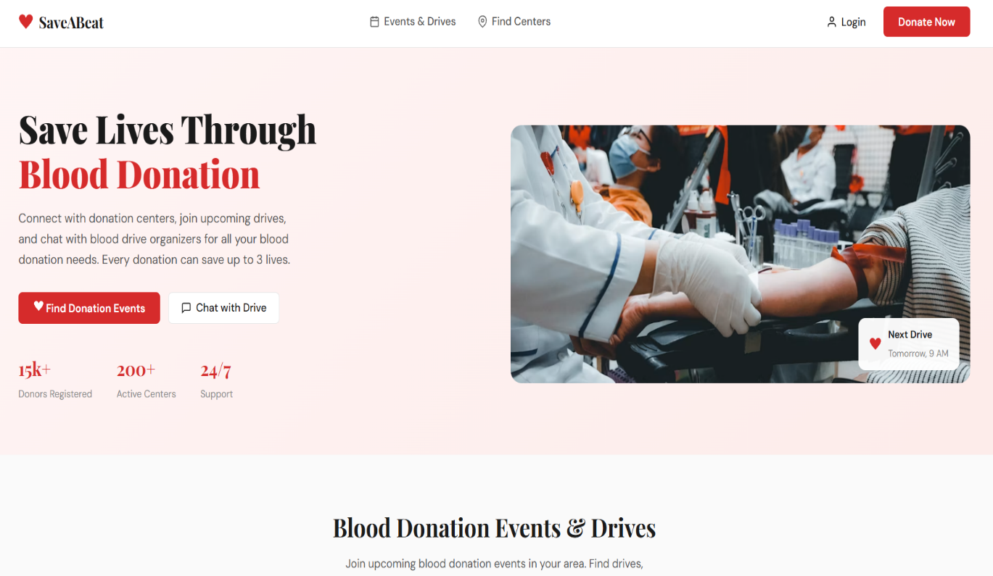

Login:

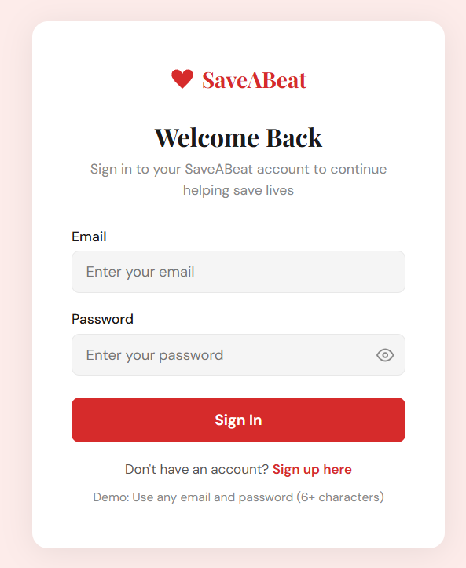
Signup:

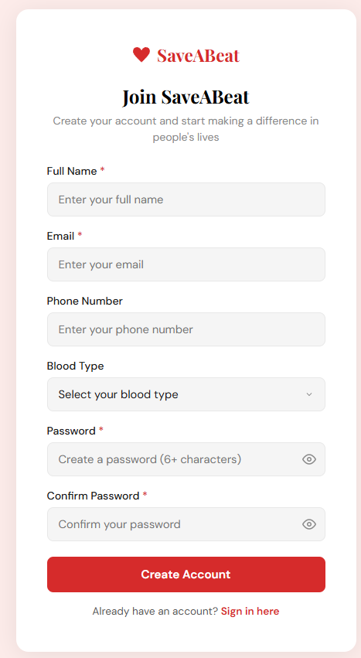
Browse Blood Drives:
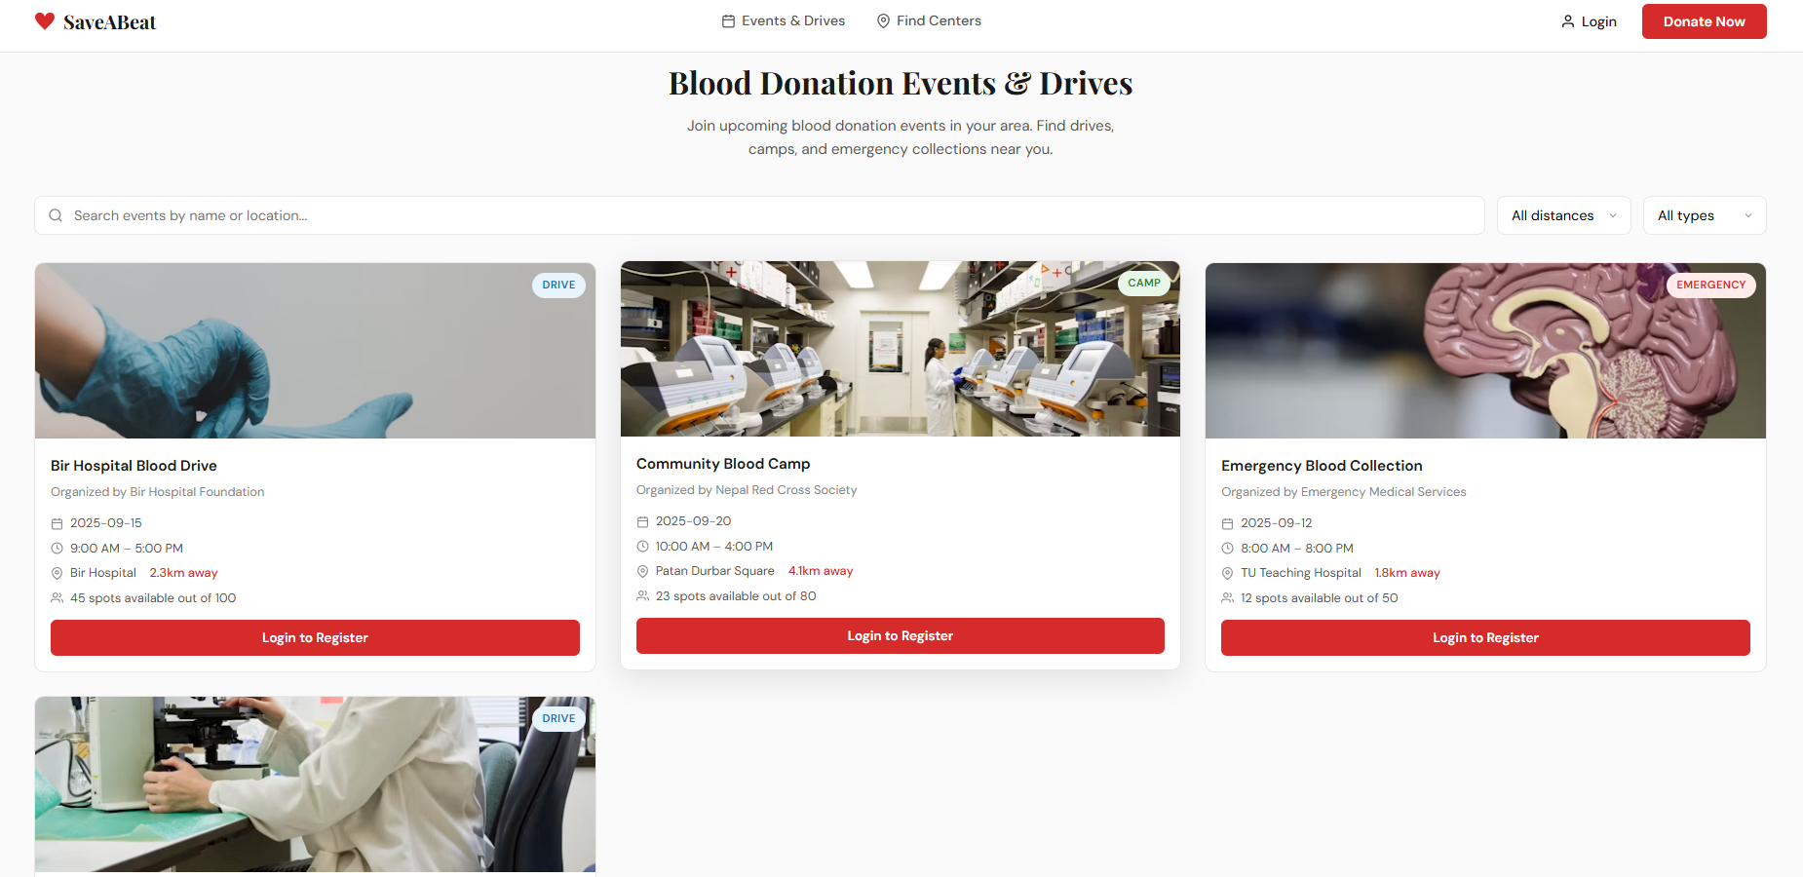

Organization :
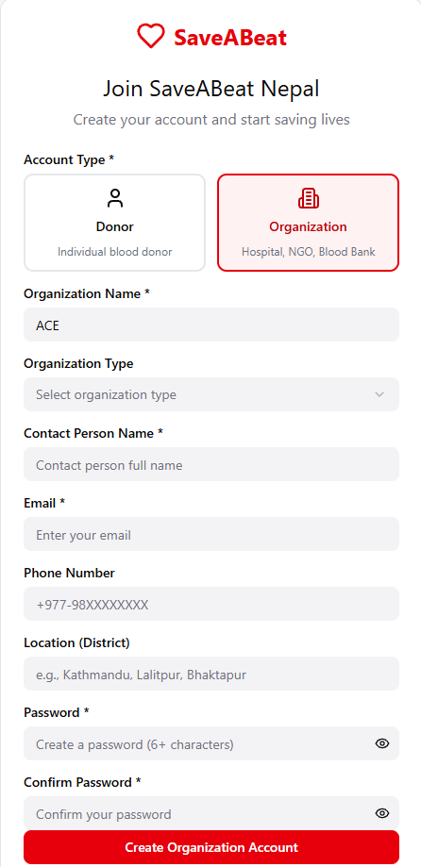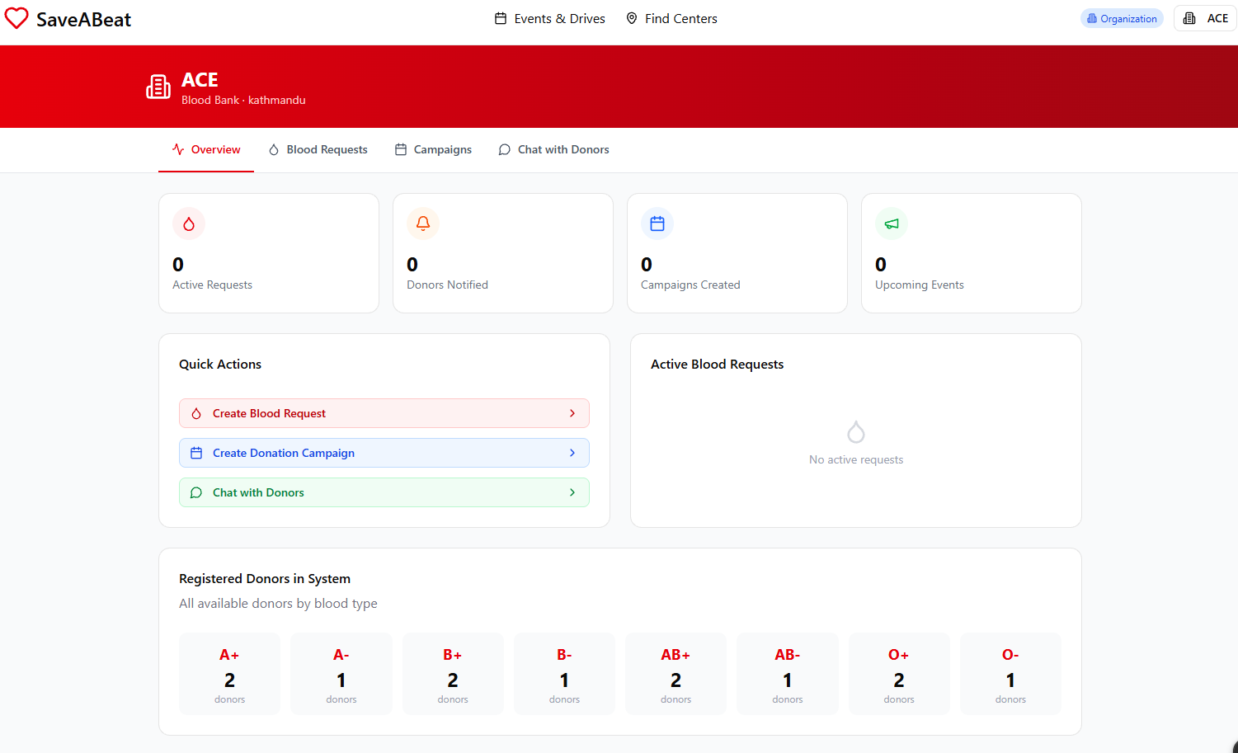

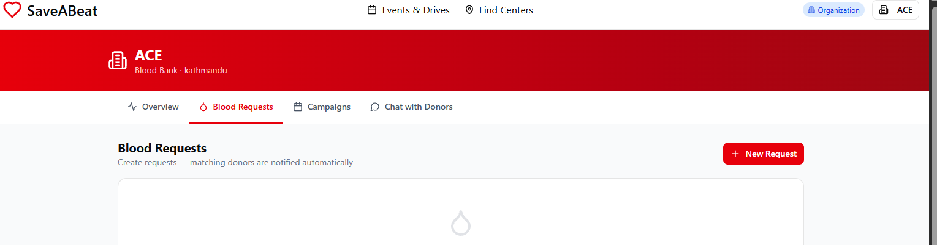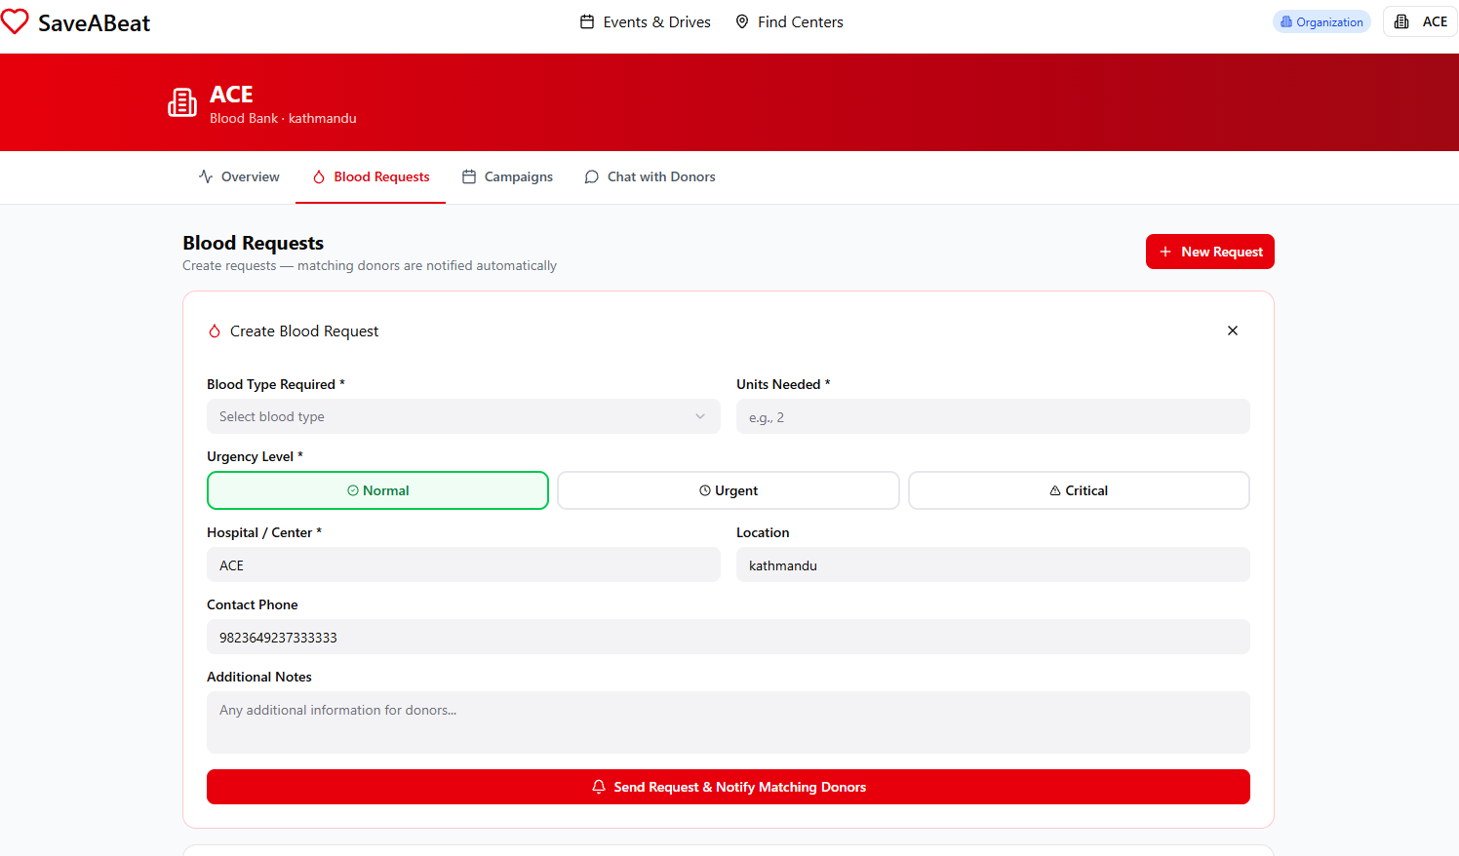
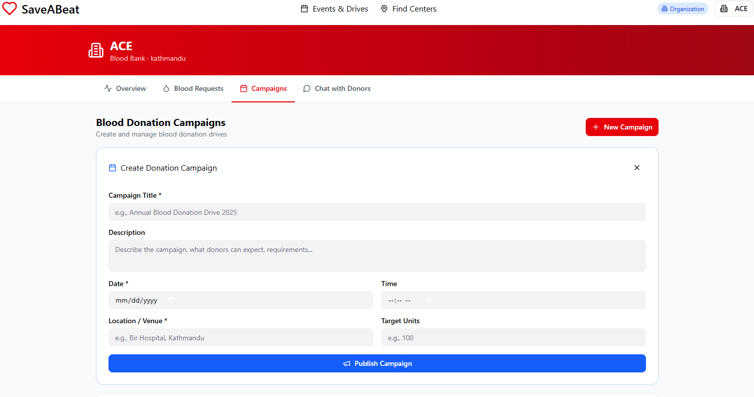
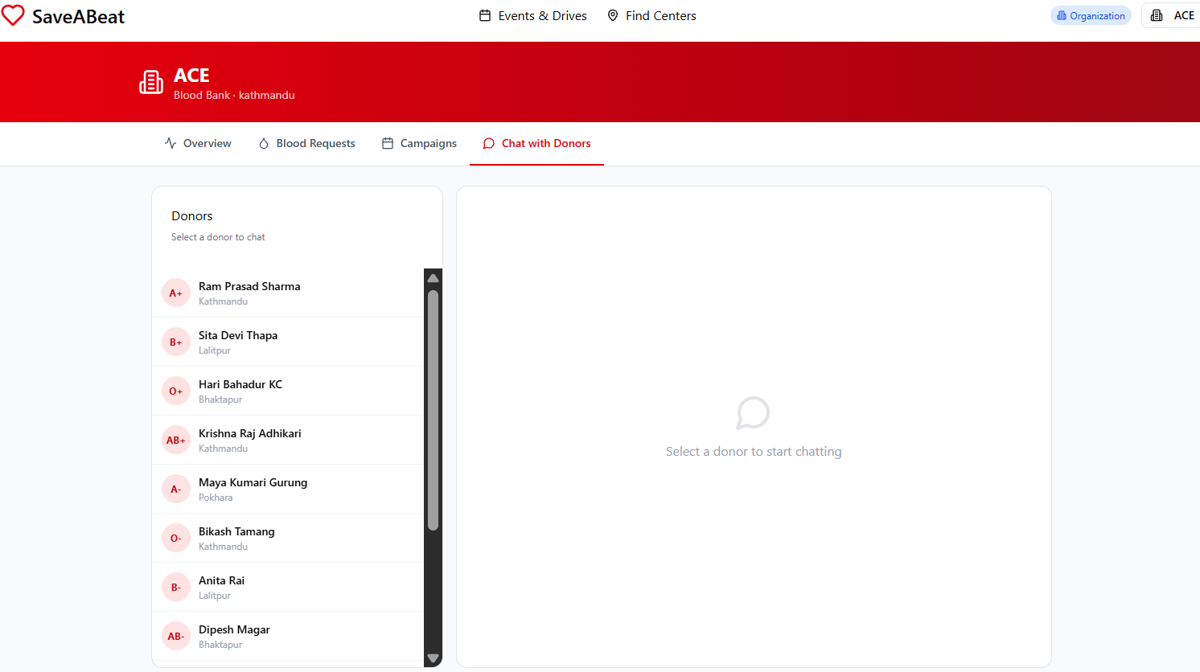

REFERENCES
- Mdpi.com. (2023). A systematic literature review of the blood supply chain through bibliometric analysis and taxonomy. Systems, 11(3), 124. https://www.mdpi.com/2079-8954/11/3/124
- NepJOL. (2023). Knowledge, attitude and practice of voluntary blood donation among higher education students in Nepal. PJRI. https://nepjol.info/index.php/pjri/article/download/87678/66464
- ScienceDirect. (2023). Impact of natural disasters and pandemics on blood supply: A systematic review. https://www.sciencedirect.com/science/article/pii/S2772632023000132
- ResearchGate. (2024). Blood transfusion services in Nepal: An overview. https://www.researchgate.net/publication/394055105_Blood_transfusion_services_in_Nepal_An_overview
- BloodConnect. Blood donor connection platform. https://bloodconnect.org/
- Sankalp India Foundation / HamroLifeBank. Blood donation app for Nepal. https://hamrolifebank.com/

